Composite Pattern:
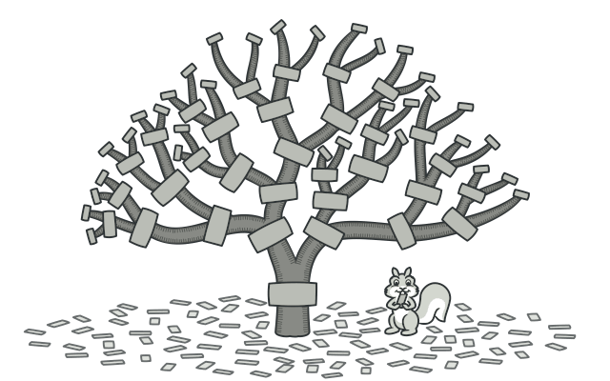

Lets you compose objects into tree structures and then work with these structures as if they were individual objects.
When to use: Representing a UI component tree (e.g., DOM, React component tree).

Decorator Pattern:
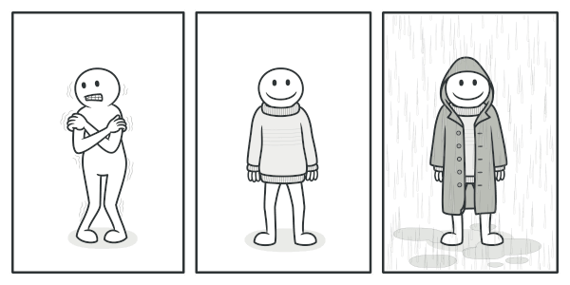

lets you attach new behaviors to objects by placing these objects inside special wrapper objects that contain the behaviors.
When to use:
- Adding additional functionalities to UI components (e.g., adding logging, styling, validation).
- Enhancing React components using Higher-Order Components (HOCs) or custom hooks.
- Middleware functions in frameworks like Express.

Factory Pattern:
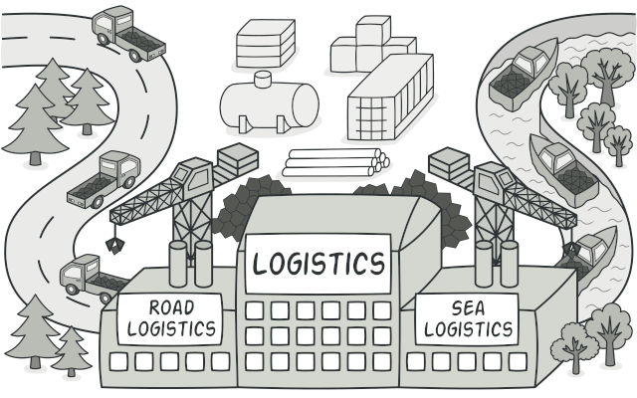
The Factory Pattern provides an interface for creating objects, but allows subclasses to alter the type of objects that will be created.

When to use:
- Creating different components dynamically based on input.
- Generating various types of charts, buttons, or UI elements.
- Abstracting the creation of objects with shared interface.

Module Pattern:

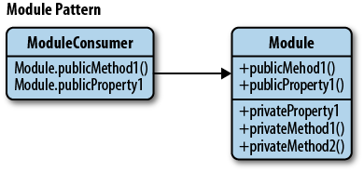

Encapsulate related functionalities into a single object, limiting the scope of variables and methods to avoid polluting the global namespace. It's a way of achieving privacy and organization, similar to namespaces.

When to use:
- Encapsulating utility functions (e.g., date formatting, validation helpers).
- Creating services or APIs in frontend apps (e.g., authentication, data fetching modules).
- Managing application state in vanilla JS apps.
- Organizing configuration and constants.
- Wrapping third-party libraries to provide a consistent interface.

Observer Pattern:
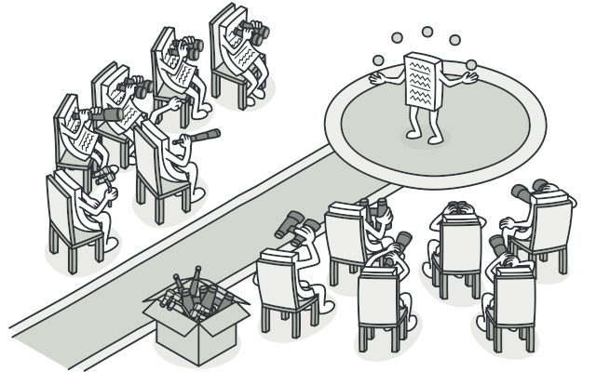

Defines a one-to-many relationship between objects so that when one object changes state, all its dependents are notified and updated automatically.

- Implementing event systems (like the EventEmitter).
- State management libraries (e.g., Redux, Zustand) to reactively update UI components.
- Real-time data updates (e.g., chat applications, notifications).

The Proxy Pattern:

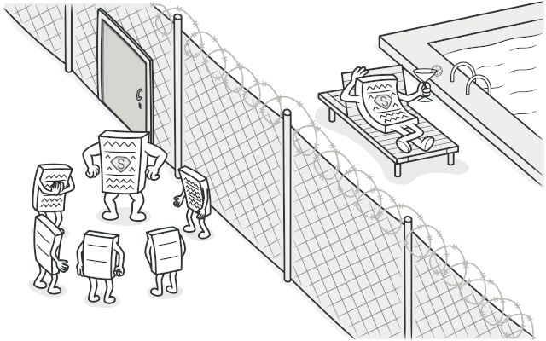

- Intercepting requests/responses (e.g., logging, caching, or modifying network requests).
- Implementing lazy loading of images or components.
- Protecting access to sensitive parts of an application (like APIs).
- Virtual scrolling or infinite scroll lists (loading data as needed).
- Data validation and sanitization before updating state or sending to server.
- Creating mock APIs for frontend development/testing.

The Singleton Pattern:
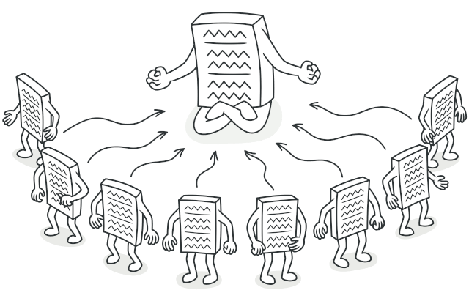
Ensures a class only has one instance and provides a global point of access to it.
- Managing global application state (like a centralized store, e.g., Redux store).
- Implementing a service for API calls or configuration settings.
- Handling browser storage (localStorage, sessionStorage) through a single access point.
- Managing a single WebSocket connection for real-time features.
- Creating a global event bus for component communication.

The Strategy Pattern:
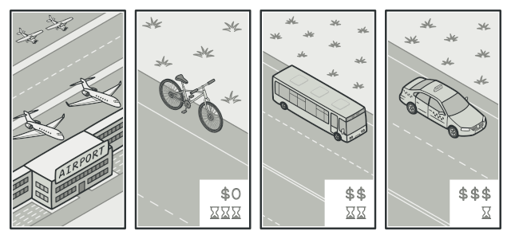
Defines a family of algorithms, encapsulates each one, and makes them interchangeable. This pattern lets the algorithm vary independently from clients that use it.

- Implementing different sorting or filtering algorithms for data.
- Handling different payment methods or authentication strategies.
- Switching between different ways of rendering components.
- To avoid complex conditional logic (like many if-else or switch statements).
- To follow the Open/Closed Principle (open for extension, closed for modification).

